INVITATION!
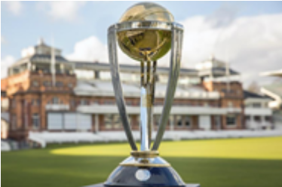

Cricket World Cup 2019 Trophy Tour
Broadhalfpenny Down
2-4pm, Sunday 24th Feb 2019

Dear Villagers,

If you would like to attend this exciting event, please let me know by Friday 15th Feb at the latest and I will inform the Trust of expected numbers.

b/w

Jo
Clerk, Hambledon PC
E-mail: clerk@hambledon-pc.gov.uk
As part of the UK leg of the Cricket World Cup 2019 - Trophy Tour, the CWC Trophy will pay a visit to historic Broadhalfpenny Down, the 'Cradle of Cricket', between 2 and 4 pm on Sunday 24th Feb 2019. There will be opportunities to:

- have your photograph taken with the trophy;
- take part in some cricket activity with Hampshire Cricket Board coaches (children only); and
- learn more about the history of the game and the important role that the men of Hambledon played in that development (from HCC Historian, Mr David Allen).

Coffee, tea and cake will be available in the pavilion and the Bat and Ball Inn is open for lunch and refreshments throughout the afternoon.
We appreciate that this will be a weather dependent activity, but an indication of numbers would be really useful.
Ground details: Hyden Farm Lane, Clanfield, PO8 0UB
Pub details: The Bat and Ball Inn, Hyden Farm Lane, Clanfield, PO8 0UB
02392632692, batandball@fullers.co.uk
Mike Beardall
Chairman
Broadhalfpenny Down Trust

