You are receiving this email because you are a key stakeholder for South East Water, and we want to keep you up to date with important news and developments.
View this email in your browser

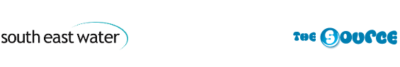

Issue 13 Winter 2017/18

Welcome to the latest issue of The Source, an update of what's going on at your local water company. For the latest news, be sure to follow us on Twitter and Facebook.

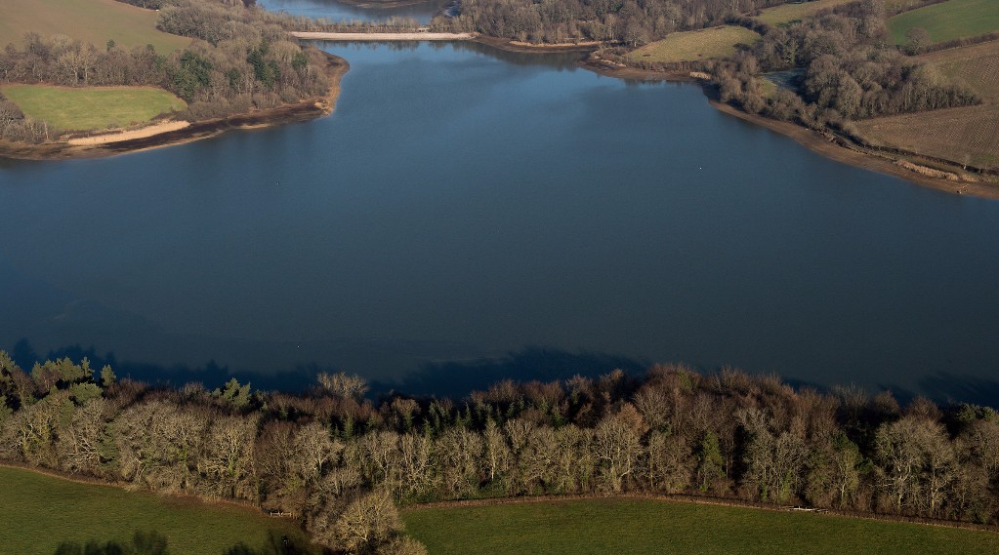
Ardingly Reservoir, near Haywards Heath, West Sussex
In this issue:
- Wrap up for winter
- Bray treatment works extension in the pipeline
- New website offers ways to save water and money
- Working in partnership to discover rare species
- Draft drought plan consultation

Above average winter rainfall needed
Due to a dry winter last year our groundwater levels started this year lower than we would like.
Similarly, the start to this year’s winter recharge season has again been drier than average in the south east, with October receiving just 40 per cent long term average rainfall.
At this point, our surface water reservoirs are in a good position, but we will need above average winter rainfall to refill during the winter recharge period overall from October to April for our underground sources to return fully to normal levels.
Lee Dance, Head of Water Resources, said: “Levels at our two reservoirs at Arlington and Ardingly in Sussex are in a good position. These reservoirs store up to 8,300 million litres of water and together provide eight per cent of all the water we supply.
“About three quarters of our supply comes from aquifers which are natural water-bearing permeable rocks deep underground where water storage levels change over a much longer period of time than in surface reservoirs. This is because it can take weeks or even months for rain water to percolate through the layers of soil and rock.
“However, we are at the start of the winter recharge season and, as always, we will be monitoring the levels closely.
“Whatever the weather we always ask our customers to use water wisely but we are stepping up the messaging even more so this year to help the recovery of these aquifers before the hot weather returns and demand increases again.”
> Read tips on how to use less water and receive free water saving devices

Wrap up for winter
Now the first frosts have formed, we’re reminding all our customers to wrap up their pipes for winter, to prevent the damage caused by burst pipes inside their home.
Insulating pipes is one of the cheapest and simplest things you can do to protect both your outdoor and indoor pipes.
All good DIY stores sell waterproof foam pipe insulation and the general rule is the thicker the insulation, the more protection you will have.
We recommend WRAS (Water Regulations Advisory Scheme) approved waterproof foam insulation as you can be sure that it has been fully tested.
> Watch our short video to see how to wrap your pipes this winter and discover more top tips

Shaping the source of future water supplies
In the new year we’ll be publishing our draft water resources management plan and will be seeking your views as part of our extensive consultation.
Against the backdrop of a growing population, the plan puts forward a number of suggestions to keep the region’s taps running over the next 60 years.
Your thoughts will be crucial to help shape the final plan which will be published towards the end of next year.
As well as seeking your feedback, we’re also working with the Water Resources in the South East group to ensure our plans tie up with those of our neighbouring water companies.
> Email us for more information

Bray treatment works extension in the pipeline
In November, we submitted a planning application to the Royal Borough of Windsor and Maidenhead for permission to extend our Bray Keleher Water Treatment Works in Berkshire.
The site is currently capable of producing up to 45 million litres of water a day but we want to increase this to 68 million litres.
Forming part of a £424 million investment programme between 2015 and 2020, the extension would secure future water supplies for customers across Berkshire, Surrey and Hampshire.

New website offers ways to save water and money
Free water-saving gadgets are on offer to South East Water customers who visit our new website.
Tap aerators, a shower timer, cistern bags, plant feeder gel and a plant moisture probe are among the products available to those interested in saving water and money on their monthly water bill.
The website also features an interactive ‘In Your Area’ map which lets customers find out about upcoming events or work affecting their water supply and sign up to email or text updates.
It also offers them the chance to register for an online account to view and download bills, check the account balance, manage a direct debit and make payments -- all from the comfort and convenience of a computer, laptop or smartphone.

Together we know h₂ow
We're busy developing our next business plan for 2020 to 2025, working with customers to understand what's important to them and shaping our plans together.
Every five years, Ofwat carries out a price review to set the price, level of investment and service package that customers receive. This includes controlling the prices water companies can charge customers.
We're engaging with hundreds of customers and stakeholders throughout the year to share our expertise and knowledge and make sure your voice is heard in our plans.
> Visit our website to find out more

Working in partnership to discover rare species
As well as producing clean drinking water, we look after 33 Sites of Special Scientific Interest, two nature reserves and numerous Areas of Outstanding Natural Beauty.
We teamed up with a bat ecologist and wildlife experts from Buglife and Natural England to discover rare bat and cricket species living on our land. The Alcathoe bat made its first recorded appearance earlier this year at our Hawkley water treatment works near Petersfield, Hampshire, in woodland surrounding the site.
Meanwhile, wildlife experts from Buglife, Natural England and our environment team are hopping with happiness after discovering Wart-biter crickets at our site at Deep Dean, in East Sussex after an absence of nearly 40 years.
Wart-biters, which get their name from the ancient Swedish medical practice of using them to eat skin warts, are endangered in the UK and only found at five sites in southern England.
The crickets need a particular kind of habitat including bare ground, short turf, wildflowers and taller clumps of grass. We have been cultivating this site for more than 20 years to make it suitable for the crickets so are thrilled that they have found a happy new home with us.
> Watch our video to see the successful release of the crickets

Our bold new look
You may have noticed we’ve been steadily introducing a new look over the last year.
Our new strapline, Pure know h₂ow, represents what we know, and how we do it, showing the technical excellence that goes into every glass of water we produce and distribute to homes and businesses along 9,000 miles of pipeline.
The distinctive new colours and message can be seen on our vehicles, website, uniform and more. As well as making us more easily recognisable for our customers, we hope that the bright makeover will protect our customers from bogus callers as our bold new look is harder to copy.

Draft drought plan consultation
We submitted our draft drought plan to Defra earlier this year after a six week public consultation period.
Now the consultation has ended, we are preparing a statement of response document which will be published on our website and sent to everyone who took part.
The plan sets out the steps we would take during periods of low rainfall to ensure we deliver a reliable water supply for customers’ essential needs. To make sure our plans are up-to-date they are reviewed every five years and a draft document is published for consultation.
> Visit our website to find out more

One Bill
Many customers have told us it's frustrating to receive a bill from us for their drinking water and another one from Southern Water for their wastewater services.
We’re really pleased to have teamed up with Southern Water to launch “One Bill” - a single bill from South East Water that includes Southern Water’s charges too.
Designed to make things simpler for our shared customers in Kent and Sussex, One Bill means customers only need to contact one company, us, to make payments for wastewater and water supply services.
A similar scheme is already in place with Thames Water for many of our customers in Surrey, Hampshire and Berkshire.
> Find out more about our new billing scheme

