Happy New Year
From your Councillors
Linda Gemmell lgemmell@winchester.gov.uk
Frank R. Pearson fpearson@winchester.gov.uk
Vicki Weston vweston@winchester.gov.uk
Take part in Local Government Consultations.
For Winchester City Council visit https://winchester.citizenspace.com
Current Consultations are: Review of Statement Principles – Gambling Act 2005 – closes 20 Jan 2019
Review of Licensing Policy – Licensing Act 2003 – closes 20 Jan 2019
For Hampshire County Council Consultations https://www.hants.gov.uk/aboutthecouncil/haveyoursay/consultations
Consultation on school admission arrangements for 2020/21 - closes 25 January
Residential Care Survey -closes 18th January
Grants
Remember to keep an eye on the Grants web page http://www.winchester.gov.uk/grants Current applications are still open for the
WINnovation - up to £4,000 closes mid day 15th Jan
Business Innovation Funed – up to £2500 opens 11th Jan and closes 28th February

Date Closes
20 Jan 2019
20 Jan 2019
See All Open Consultations

Winchester District Councillors report Jan/Feb 2019

Rough Sleepers
Should you find someone sleeping rough within the district please contact StreetLink.
StreetLink is the national service set up to enable rough sleepers to become connected with the support they need. There are three ways that you can contact StreetLink to tell them about a rough sleeper:
- Call 0300 500 0914. This is a free phone number and lines are open 24 hours a day, seven days a week.
- Visit www.streetlink.org.uk and click ‘Tell us about a rough sleeper@ and fill in as many details as possible.
- Download the mobile app (available for free from the iTunes and Google Play stores) and follow the same steps as the website.
Any details you may provide about the rough sleeper will be sent to both the housing options team at the City Council and to Trinity Winchester, the local day centre providing support for the homeless, who will aim to make direct contact the rough sleeper in order to provide relevant advice and assistance. A few days later StreetLink will follow the case up with the City Council and can provide you with an update.
Please remember that you do not need to approach anyone rough sleeping directly.
You can also contact the Housing Options Team at the City Council directly during office hours 9.00am to 5.00pm in the following ways:
Face to face with a Housing Options Officer at our drop in Triage Service based in the Customer Service Centre, via email roughsleepers@winchester.gov.uk or by telephoning the duty line on 01962 848 163.
Grants up to £5,000 plus the support of Volunteer Rangers available in 2019 for South Downs projects
Grants of up to £5,000 are available for non-profit organisations, parish councils and landowners in 2019 for projects that care for and enhance the South Downs National Park and promote opportunities for people to understand and enjoy it.
Daniel Greenwood, Volunteer Development Officer, for the South Downs National Park, said:
“Got an idea for a project in your community that the Volunteer Ranger Service can help deliver? Whether it’s refurbishing a community pond, creating a sensory garden, creating wildflower meadows or butterfly banks, this is your opportunity to make it happen.”
The grants are available thanks to the new South Downs Volunteer Conservation Fund, managed by the South Downs National Park Trust in partnership with the South Downs Volunteer Ranger Service (VRS) and to be eligible, projects must use the practical support of the VRS.
Almost any project which helps to conserve or enhance the National Park is eligible, provided it fits with the National Park Partnership Management Plan and makes use of the South Downs Volunteer Ranger Service.
The deadline to apply for the first round of funding is 31 March 2019 and the first grants will be awarded in June 2019. Find out more at www.southdownstrust.org.uk/volunteer-fund

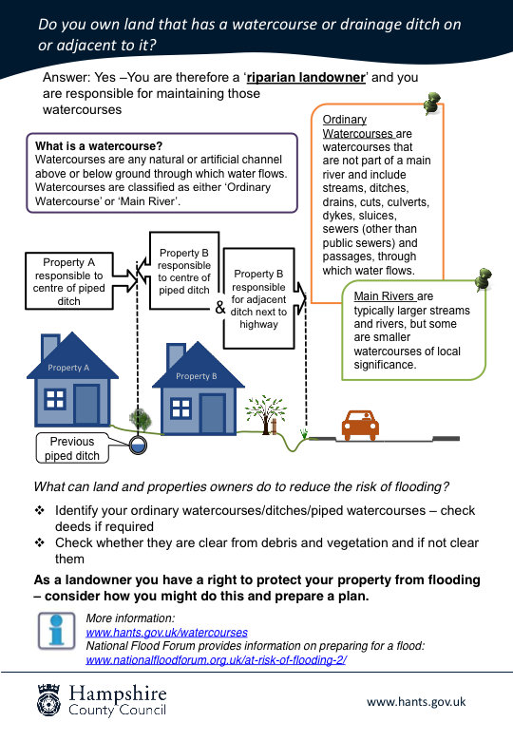
Ditches and Flood Prevention
Please ensure that all watercourse or drainage ditches are well maintained. Blocked drains cause most surface water flooding issues in our Parishes. Many open ditches have been filled in over the years and we are now having to deal with more and more flooding issues due to poorly maintained piped ditches.
A blocked pipe may be having a detrimental affect on a property up stream from you.
Kerbside Glass Collection 

A kerbside glass collection will be put in place for all households from October 2019. This is to be a free monthly collection service. The collection rounds may be changing as well for some households. More information will be communicated as soon as it is available on the details and any changes to collection days.

SDNP Local Plan Examination
https://www.southdowns.gov.uk/planning/national-park-local-plan/
The scheduled hearings for the Local Plan examination at Midhurst and Falmer have ended. The Inspector is now considering what he has heard and will be working with the National Park Authority on Main Modifications to the Local Plan. This consultation will take place in the New Year 2019.
All updated evidence and supporting documents are on pages:
Examination Page (updated regularly)
Core Document Library Page

Useful web links: SDNP Planning applications:
https://www.southdowns.gov.uk/planning/planning-applications/

Local Government article by William Eichler 04 January 2019
Councils approve planning applications at ‘fastest rate’ in a decade

Local authorities are approving planning applications at their fastest rate in over a decade, a homelessness charity has revealed.
Figures released by Shelter show that in 2017/18 87% of major residential planning applications were decided within 13 weeks or the agreed time limit.
This compares to 2012/13 when 47% of major residential planning applications - the lowest figure on record - were decided within 13 weeks or the agreed time limit.
Shelter also discovered that there was a 22% rise in the proportion of minor residential planning applications decided within eight weeks or the agreed time limit between 2012/13 and 2017/18.
In 2012/13 three in five (60%) minor residential planning applications were decided within eight weeks or the agreed time limit. By 2017/18, this had increased to four in five (82%).
‘Developers often blame the planning system for their failure to build the kinds of homes families need but these figures show that’s a myth,’ said Greg Beales, campaign director at Shelter.
Criticisms of the planning system are often used to justify the extension of permitted development rights (PDRs), which allow builders to circumvent councils when converting commercial property.
Mr Beales is concerned that the Government is planning to further extend PDRs to demolished commercial buildings which he argues could lead to poor quality and unaffordable housing.
‘That’s why the Government shouldn't go ahead with its plans to further dismantle the system - and gift developers yet another get-out clause to avoid social house building obligations,’ he said.
‘Instead of worsening our housing emergency by de-regulating planning, we need to invest in social housing to build the homes people really need.’

