

NEWSLETTER JANUARY 2019
Dates for Your Diary
Hambledon Pre-school’s Grand Jumble Sale!
Saturday 26th January 2019; 12.00 – 1.30 pm; Hambledon Village Hall
clothes * accessories * toys * unopened toiletries * books * gifts *
cake sale
Please bring along good quality items to the village hall from 9 am on the day or, if you cannot donate on the day, contact Hambledon Pre-School on 92 632 242.

M27 night-time closures
The main construction of the M27 Junction 4 to 11 smart motorway will start in early January between junctions 4 and 8.

The work will take place between 10:00 and 06:00 on the following dates:

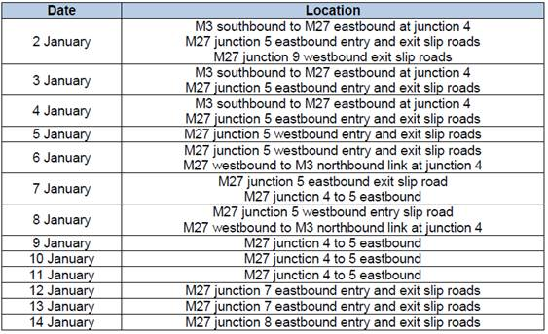

News from Winchester City Council

Arts News
Winchester City Council's Arts pages
Welcome from Cllr Rob Humby, Winchester City Council's Deputy Leader and Portfolio Holder for Business Partnerships.
Arts News is the electronic newsletter for arts practitioners. Let us know if there is any news you would like us to cover so that we can make this newsletter useful for you, our creative community.
January 2019 - this edition includes:
- Winchester Cultural Network meeting
- WINnovation funding for cultural organisations
- Year of progress for the regeneration of central Winchester
- Aesthetica Art Prize 2019
- Courses at The Nutshell
- Cabinet on the road
- Made in Dagenham
- A Christmas Carol
- Michael Frayn in conversation

WINnovation Funding for Cultural Organisations
Winchester City Council has reviewed its grant programme for 2019/20 and the new funds and application approach will be implemented over the next six months. So that cultural projects do not miss out during this transition period the WINnovation grant is being opened up to cultural organisations in this current funding call. This is to enable cultural organisations to bid for projects that will be delivered in the spring and summer of 2019.
We are inviting not for profit/voluntary/charitable groups to apply for up to £4000 for community projects, activities or one-off pieces of equipment.
We are only looking to fund initiatives which are delivered in an entrepreneurial way that are innovative, engaging, capacity building or enhance the organisation's strategic development.
Short listed applicants will be invited to a mentoring session on 24 Jan in order for them to ask questions and to refine their pitches in time for the event on 5 Feb, 3.30pm to 7pm at the Guildhall in Winchester.
The deadline for applications is noon on Tues 15 Jan 2019. Full details on who can apply and how to apply can be found on the WINnovation website.
For further information contact Economy and Arts Support Officers, Carol Hussey and Zoe Sipsma - Mon to Fri.Tel: 01962 848 196 or
01962 848 303; Email: businessgrants@winchester.gov.uk; or
Funding and Development Officer, Melissa Fletcher - Tues to Thurs.
Tel: 01962 848 492; Email: mfletcher@winchester.gov.uk

Aesthetica Art Prize 2019

Celebrating excellence in art from across the world and hosted by the international publication Aesthetica Magazine, the Art Prize supports innovation across a range of media and offers individuals the opportunity to elevate their practice on the world stage.

Artists have the chance to win £5,000, as well as participation in an internationally renowned exhibition and publication with Aesthetica. Art supplies from Prestel and Cass Art are also part of the prizes on offer.
Submissions are now being accepted. The closing date is 31 August 2019.
Full details and how to apply can be found here.

Courses at The Nutshell

The Discarded Nut Theatre Company has announced the new programme of workshops being held at The Nutshell, Kings Walk, Winchester, from January 2019:
• The Walnuts; for anyone aged 18+
• Play Time; a book club with a difference where you read and talk about incredible scripts together
• Stage Combat; learn all the skills needed to create some of the most dramatic moments from a few of the greatest plays
• Story Time; for babies and toddlers, sensory and interactive sessions with Beccy the Buccaneer and her mischievous parrot, Pablo
All these workshops are taking place alongside:
• Monkey Nuts Youth Theatre, for ages 7 to 11
• Musical Theatre Young Company, for ages 4 to 12
• Discarded Nut Youth Theatre, ages 11 to 25
Discarded Nut is also presenting a masterclass workshop on audition techniques with Animate Theatre Company on Tues 8 Jan from 6.30pm to 9.30pm. A must for anyone applying to drama school this year. Whatever your age, get involved. To find out more and to sign up go to The Nutshell’s website.

Cabinet on the road

Ever wondered what happens at a council cabinet meeting? Winchester City Council’s cabinet is made up of eight councillors who are responsible for all operational decisions. They are taking their meetings on the road around the district. Join them on Wed 23 Jan 2019 from 4.30pm at the Woodford Suite, Wickham Centre, Mill Lane, Wickham.

Made in Dagenham

Audition nights for Winchester Musicals and Opera Society 2019 presentation take place on:
• Mon 7 Jan - information evening - come and listen to the director and musical director talk about the show. All welcome
• Wed 9 and Mon 14 January - pre-audition rehearsals
• Wed 16 Jan - auditions
All the events take place at 7.30pm in United Church on Jewry Street, SO23 8RZ.

Central Winchester Regeneration

Sign up to receive central Winchester regeneration updates by going to: www.winchester.gov.uk/cwrsignup

Michael Frayn in Conversation with John Miller


AQUIND Interconnector

For an update regarding the AQUIND interconnector, please visit the following page on the PC website http://www.hambledon-pc.gov.uk/Article/Detail.aspx?ArticleUid=4d2501c0-a126-4978-8e6f-23b32b08a9a3

Please note that the following has also been received from the AQUIND Community Relations Team:

“It has come to our attention that some residents have encountered technical difficulties when attempting to contact WSP’s Land Referencing team using a telephone number listed within a recent correspondence regarding the Land Interest Questionnaire (LIQ) process for AQUIND Interconnector. Due to an administrative error, an incorrect number was provided within this correspondence and we would like to apologise for any inconvenience caused. All other contact details provided were correct. WSP’s Land Referencing team can be contacted via 020 3116 9389 or via aquindinterconnector@wsp.com. Further information regarding the LIQ process can be found on the FAQ page of this website https://aquindconsultation.co.uk/”

