Hampshire County Council Divisional Report for Hambledon Parish Council

Hampshire County Council marks the Armistice Centenary. There will be a range of county wide public events with a special programme of events up until the end of November to commemorate the centenary of the end of World War One

Leader of Hampshire County Council, Councillor Roy Perry, said: “Every year, towns and villages across the county join others worldwide in falling silent to mark Armistice Day on Remembrance Sunday. This year’s events take on a special significance as the 100th anniversary of the ceasefire approaches.
“Even 100 years on, we can still feel how Hampshire was changed by the Great War; the tremendous losses during the war, and the years of hardship that followed, all left their mark. It is fitting that we now remember the courage of those who fought in the conflict, their sacrifices, and those of their families, loved ones and communities at home.”
The County Council’s programme of World War One centenary events includes:
• 6 November - Dearest Mother: A First World War Story - multimedia presentation and readings bringing to life the letters of Winchester’s John Baines, a young officer in the Royal Engineers at Hampshire Records Office, Winchester (6pm)
• 9 November - a spectacular projection of cascading poppies on the Great Hall, Winchester (6-10pm) to commemorate the end of World War One

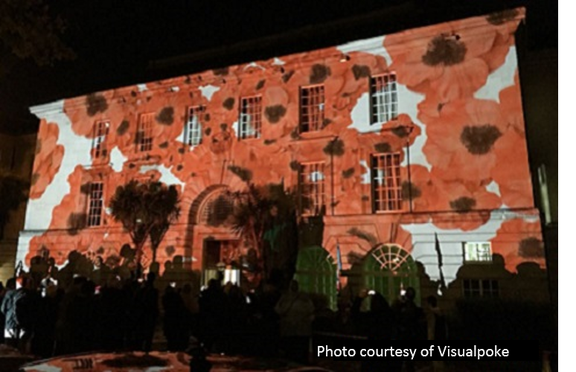
Councillor Elaine Still, the Chairman of Hampshire County Council said: "I hope the sight of poppies flowing down the Great Hall will be a strong visual reminder for residents of the bravery and sacrifice of those who lost their lives during World War One. All at the County Council are extremely proud of our Armed Forces and this act of remembrance demonstrates our continued commitment to those currently serving, our veterans, as well as honouring all those who have fallen in conflict. “This installation will be on throughout Friday evening, and I would like to invite residents and visitors to come along and take a moment to remember those who have lost their lives serving our country.”
• 10 November - a concert of 20th century wartime and swing tunes at the Royal Victoria Country Park Chapel, Netley, (formerly the Royal Military Hospital), (3pm and 7pm) featuring young musicians and singers from the Hampshire Music Service
• 12 November - a royal visit by the Countess of Wessex to Royal Victoria Country Park, Netley, to officially open the restored Chapel
• 17 November - a Peace and Reconciliation Concert at Romsey Abbey, featuring the Hampshire County Youth Orchestra accompanying a choir of young people from Giessen, Germany
• October/November – a programme of exhibitions and talks in local libraries and discovery centres, including displays of handmade poppies and ‘Tommy silhouettes’ which depict the shadows of soldiers left absent in the wake of the war
• A 100-word writing competition for children and adults on a WW1 theme, winning entries to be published in a booklet.
In addition, Councillor Perry, as Leader of the County Council, along with other County Council representatives, will be attending the special Service of Remembrance at Winchester Cathedral on Sunday, 11 November at 10am, and the Royal British Legion’s Festival of Remembrance at the Mayflower Theatre, Southampton, that evening.
View the full programme of events and other commemoration information https://www.hants.gov.uk/firstworldwar
Hampshire County Council fully supports the Silent Soldier movement to commemorate the centenary of the end of the First World War. We would ask parish councils and communities wishing to install a silent soldier on the public highway to contact Hampshire Highways direct on 0300 555 1388 in order to ensure that the chosen location is safe; in the circumstances we will not be charging a fee for licensing these memorials.
It’s Meals on Wheels Week 5-9 November – find out more about the Hampshire service – now available to younger adults. Hampshire County Council has started a new Meals on Wheels Service, offering hot meals to adults aged 18+ who have difficulty preparing food, and managing and maintaining nutrition
Delivered by Meals on Wheels provider ‘apetito’, the service is now available to young and older adults, including those who have dementia, a learning disability, a mental health issue, a history of substance misuse, or a physical disability. “In addition to the meals’ nutritional value, which is so important to good physical and mental health, the Meals on Wheels visit is sometimes the only social interaction a person may have all day – in this way, the service also plays a valuable role in helping to prevent social isolation.”
The County Council’s Meals on Wheels service delivers a two-course hot lunchtime meal, with the additional option of afternoon tea. Meals on Wheels drivers are trained to carry out a wellbeing check in addition to the delivery of the meal. This ensures that wellbeing and safety concerns are identified, and action taken in a timely way. Drivers report concerns to the relevant Hampshire County Council team or call for emergency services where necessary.
The current cost is £4.67 for a daily two course meal and £3.25 for afternoon tea.
Those who receive the Meals on Wheels service have been assessed as having a need for support to manage and maintain nutrition.
Further information is available at https://www.hants.gov.uk/socialcareandhealth/adultsocialcare/olderpeople/mealsonwheels
Cllr Roger Huxstep
Member for Meon Valley Division 5th November 2018

